Software Requirements Specification (SRS)

**Product**: AI Co Founder for E Commerce (ShopPilot)  
**Version**: 1.3  
**Date**: 20 September 2025  
**Owner**: E Commerce and FinTech Stream

# 1. Introduction

## 1.1 Purpose

This document explains the requirements for the AI Co Founder system. The goal is to support solo and small e commerce owners by providing an assistant that can manage daily operations. The system will help with setting up stores, recovering abandoned carts, handling inventory, improving content and search ranking, and running marketing campaigns. All activities will follow ethical standards and include human approvals.

## 1.2 Scope

The system is a chat first dashboard that connects with different platforms. It will provide a central place where business owners can type natural language commands to manage their store. The main focus of the prototype is cart recovery and basic integration with Shopify, Klaviyo, and n8n. Other functions like inventory, content, and marketing are included at a simple level. The full production system can be extended later.

## 1.3 Definitions

* HITL means Human in the Loop
* MCP means Model Context Protocol
* LLM means Large Language Model
* GDPR means General Data Protection Regulation
* SEM means Search Engine Marketing

## 1.4 Overview

The rest of this document describes the system context, features, data model, and non functional requirements. It also includes the current progress and the roadmap.

# 2. Overall Description

## 2.1 Product Perspective

The product is a web application built with React and Tailwind CSS. It connects to a backend API written in Node and Express. The backend calls MCP clients and servers that run on FastAPI. Automation tasks are executed by n8n running in Docker. Local LLMs through Ollama are used to provide content generation and analysis.

## 2.2 Product Functions

* Conversational AI chat with natural language commands
* Cart recovery agent to detect abandoned carts and send recovery messages
* Inventory agent to check stock levels and suggest reorders
* SEO and content agent to generate product descriptions and blogs
* Marketing agent to plan simple ad campaigns
* Dashboard with key metrics and notifications
* Settings and approvals for ethical controls and privacy

## 2.3 Users

* Owner: full control and approval rights
* Marketer: focus on campaigns and templates
* Analyst: focus on insights and reports
* Viewer: read only access

## 2.4 Constraints

The system in prototype runs on local development environments. No paid infrastructure is used. Data from Shopify and Klaviyo is limited to test accounts and sample CSV.

# 3. System Architecture

The frontend interacts with the backend API. The backend communicates with MCP clients and servers. Workflows are triggered through n8n. External platforms such as Shopify and Klaviyo provide store and customer data. Ollama models provide language generation locally.

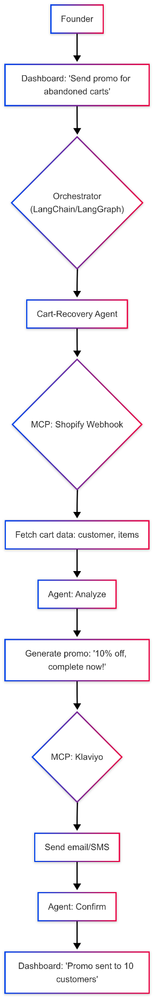

# 4. System Features

Each feature is described with a user story and acceptance criteria.

## 4.1 Dashboard and Navigation

User Story: As a business owner I want a dashboard with clear navigation so that I can find all features easily  
Acceptance Criteria: The sidebar shows links to all main pages. The active page is highlighted. On mobile the sidebar collapses into a menu. The system saves the theme preference.

## 4.2 Conversational AI

User Story: As a business owner I want to control operations using natural language so that I can work faster  
Acceptance Criteria: A chat button is available on all pages. When I type a request the system routes it to the correct agent. The system gives progress updates and shows outputs such as charts or approval buttons.

## 4.3 Home Dashboard

User Story: As a business owner I want a home page with metrics so that I can see my store performance  
Acceptance Criteria: The page shows cart recovery rates, revenue uplift, time savings, and alerts. Charts update in real time. Quick approval buttons are available.

## 4.4 Setup Wizard

User Story: As a new user I want a step by step setup with OAuth integration so that I can connect my store quickly  
Acceptance Criteria: On first login the system shows a wizard. There are one click buttons to connect Shopify and Klaviyo. Test data is imported. Preferences such as brand tone and discount ranges are collected.

## 4.5 Cart Recovery Agent

User Story: As a business owner I want to recover abandoned carts so that I can increase sales  
Acceptance Criteria: Abandoned carts are detected after a set time. The system generates personalized recovery messages by email or SMS. A dashboard shows metrics such as click rate and revenue recovered. A demo mode is available with sample carts.

## 4.6 Inventory Agent

User Story: As a business owner I want to manage stock so that I can avoid running out of products  
Acceptance Criteria: The system shows stock levels and alerts for low stock. Automatic reorder rules can be set. Predictions are displayed based on sales trends.

## 4.7 Marketing Agent

User Story: As a business owner I want to run campaigns so that I can attract more customers  
Acceptance Criteria: Campaigns can be planned and reviewed. The system shows ad spend and return on investment. Quick launch and approve options are available.

## 4.8 SEO and Content Agent

User Story: As a business owner I want to generate optimized content so that I can improve search ranking  
Acceptance Criteria: The system suggests keywords and produces content. Ranking and traffic uplift are displayed.

## 4.9 Settings and Approvals

User Story: As a business owner I want centralized approvals so that I can control spending and ethics  
Acceptance Criteria: The system requires approval before running sensitive actions. API keys and data flags can be managed. Logs and performance data are shown.

## 4.10 Accessibility

User Story: As a user with accessibility needs I want full access so that I can use the application  
Acceptance Criteria: The system supports keyboard navigation, ARIA labels, high contrast mode, and clear validation messages.

## 4.11 Dark Mode

Acceptance Criteria: The system detects the theme preference and applies it consistently.

## 4.12 Mobile Support

Acceptance Criteria: The layout adapts to mobile screens. Charts and tables are scrollable. Touch gestures work smoothly.

## 4.13 Performance

Acceptance Criteria: The application loads in under three seconds. Updates happen in real time without freezing the interface.

# 5. Data Model

Entities include User, Store, Customer, Product, Cart, CartItem, Segment, Template, Campaign, CampaignSend, MessageEvent, Job, Approval, and AuditLog.

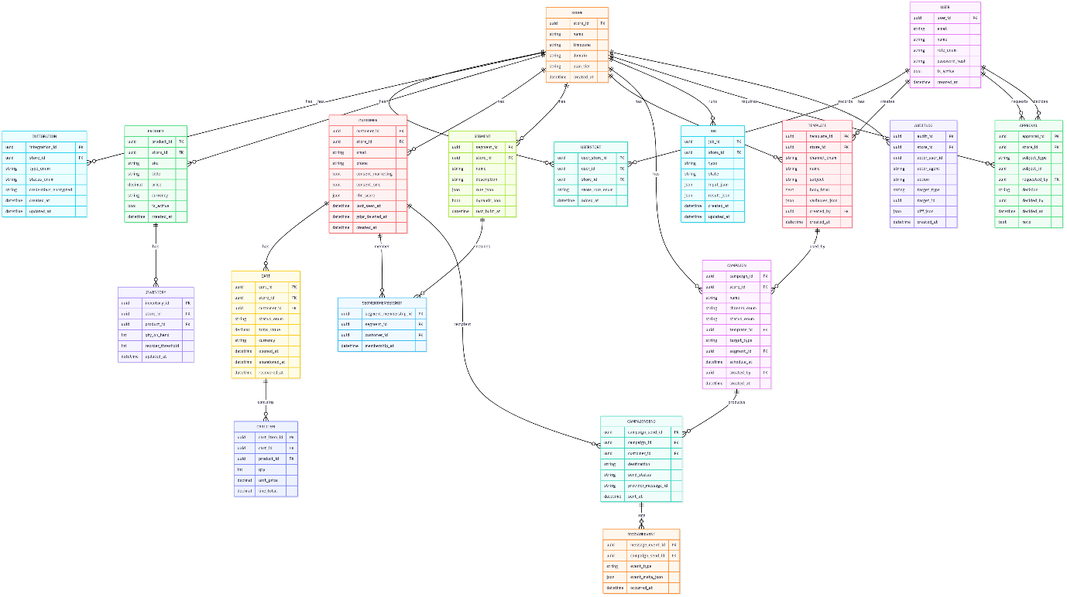

# 6. Non Functional Requirements

* Performance: fast response times and smooth updates
* Reliability: target availability at 99.5 percent in prototype
* Security: HTTPS in production, secrets in environment files, role based access
* Privacy: GDPR compliance, user data export and delete options
* Usability: simple navigation, accessible design, mobile friendly
* Maintainability: modular agents and workflows, clear code structure
* Observability: logs, health checks, job metrics

# 7. Ethical AI

The system applies bias checks, requires human approval for sensitive actions, and records activity logs. Only minimal data is processed. Customer consent is respected.

# 8. Current Progress

The prototype has a working chat interface, a minimal MCP server, a cart analysis tool tested with synthetic data, and basic n8n workflows. A local stack with Ollama provides generation. A React dashboard shows metrics and alerts.

# 9. MVP Acceptance

The system must be able to import at least two hundred mock customers, create a segment, generate a template, send a test campaign, and show metrics. The chat must support tool listing and require a confirm step before sending.

# 10. Roadmap

Sprint 3 will add segmentation UI and analytics. Sprint 4 will expand inventory and marketing functions and prepare a VPS deployment. Sprint 5 will improve security, add billing, and support multiple tenants.

# 11. Appendices

## Ecosystem diagram

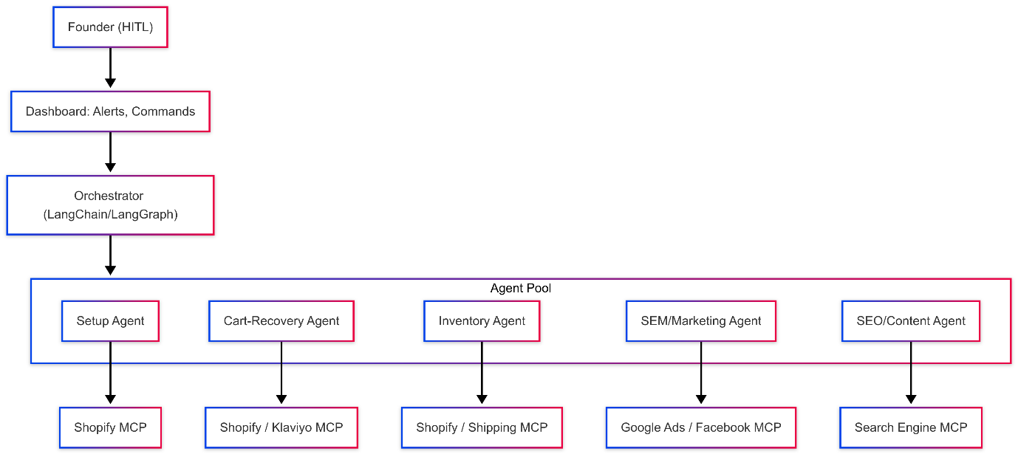

## System context diagram



## Home dashboard wireframe

## Cart recovery flow diagram

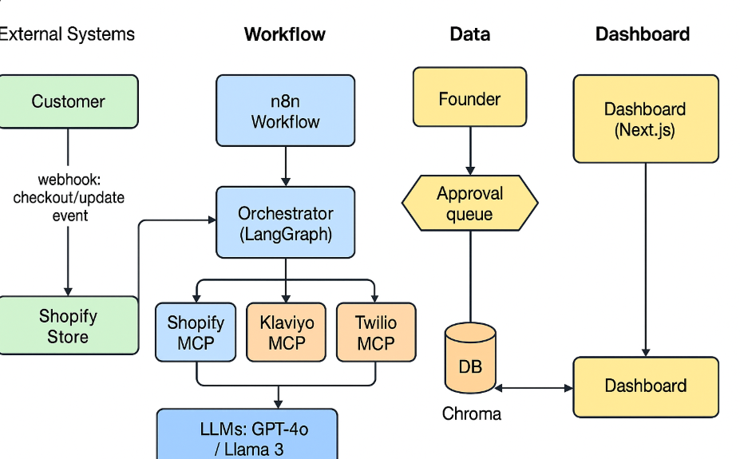

## ER diagram

## n8n configuration screenshot